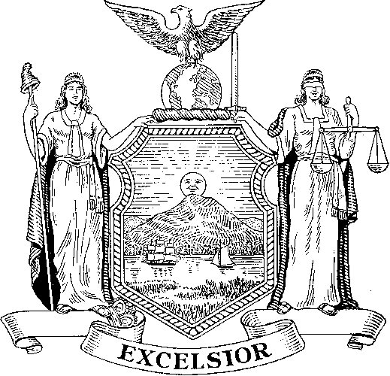
New York State Department of

TAXATION and FINANCE

OTPA Sales Tax Exempt Organizations Unit
Building 9 Room 154
W.A. Harriman Campus
Albany, NY 12227

July 28, 2026

State University of New York
College at Old Westbury
PO Box 210
Old Westbury NY 11568

Dear Sir or Madam:

The Tax Law exempts New York State governmental entities such as your organization, State University of New York, from the payment of New York State sales and use taxes on their purchases. In order to make tax exempt purchases, a New York State governmental entity must present vendors with the entity's official purchase order or other documentation (e.g., payment voucher, contract of sale, Form AC946, Tax Exemption Certificate, Form ST-129, Exemption Certificate - Tax on occupancy of hotel rooms, etc.) which indicates that the purchaser is a New York State governmental entity.

Tax exemption numbers and Form ST-119.1, Exempt Organization Exempt Purchase Certificate, are not issued to New York State governmental entities. If a vendor requests a tax exemption number or Form ST-119.1, Exempt Organization Exempt Purchase Certificate from you, the State University of New York may give the vendor a copy of this letter. This will assure the vendor that a governmental purchase order, or other evidence that the State University of New York is the purchaser, is the only documentation the vendor needs in order to not collect sales tax.

New York State Department of Taxation and Finance
OTPA-Taxpayer Guidance Division
Sales Tax - Exempt Organizations Unit
Building 9, Room 154
W.A. Harriman Campus
Albany, NY 12227
(518) 457-2782

TIN: 14740026K

