Speaker(s) | Presentation | Time | Room
 | Continental Breakfast & Registration | 8:00am | NAB 1100
  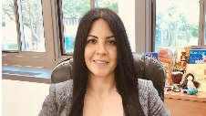  Priscilla Zárate &  Richard Bellis | Session 1-  Safeguarding the Education & Rights of NYS Immigrant  Students: A Compliance-Centered Approach" | 9:00am | NAB 1105
    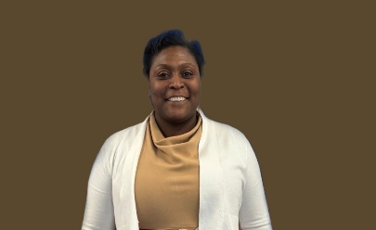    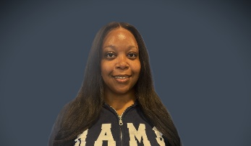  Dr. Arabelle Pembroke, Jarena Brown, Rolande Elie, Elia Martinez, Lenox Small | Session 2-  "Special Education and Inclusive Practices" | 10:45am | NAB 1103
 | Working Lunch & Reflection/Networking | 12:05pm | NAB 1100
  Dr. Marty Cooper | Session 3-  Prioritizing Wellness: Mental Health and  Self-Care Strategies for Educators | 1:00pm | NAB 1105
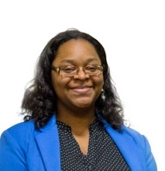  Renata Robinson-Glenn | Session 4-  Cultivating In-Depth Understanding  Through Project Based Learning | 2:00pm | NAB 1103
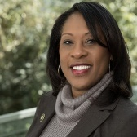  Dr. Diana Sukhram | Closing Address | 3:00pm | NAB 1103

