July 15th Conference Schedule
Speaker(s) | Session Topic | Time
 | Continental Breakfast & Registration | 8:00am-8:50am
Yolanda Sealey-Ruiz, Ph.D. | Session 1- Rigor, Relevance, Relationships: The Fundamentals of Culturally Responsive Pedagogy | 9:00am-10:30am
Dr. Kenneth Card, Interim Superintendent Elmont Union Free School | Session 2- Online/Zoom ONLY  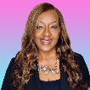  Superintendents Panel Discussion: Promoting Culturally Responsive Practices and Care in Education  Panelists:  Ms. Regina Armstrong,  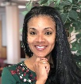  Superintendent of Hempstead Schools  Dr. Roxanne Garcia-France,  Superintendent of Valley Stream 30  Mr. Marlon Small,  Superintendent of Greenport UFSD | 10:40am-12:10pm
Organization Spotlight:  Mauer Foundation | Working Lunch & Reflection/Networking | 12:10pm-1:00pm
André Benito Mountain, Ed.S. | Session 3- The Hip Hop & Jazz Literacy Laboratory | 1:10pm-2:40pm
Dr. Maureen Gillette | Session 4- Creating & Sustaining Equitable Classrooms, Schools, and Districts | 2:50pm-4:20pm
Mason Mason | Session 5- Educational Technology and Apple Inc. | 4:30pm-5:30pm
July 16th Conference Schedule
Speaker(s) | Session Topic | Time
 | Continental Breakfast & Registration | 8:00am-8:50am
Dr. C. Edward Watson | Session 1- AI’s Implications for Higher Education: Preparing Students for Life Beyond College | 9:00am-10:30am
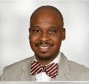  Dr. Bryant Marks | Session 2- Online/Zoom ONLY  The Hidden Biases of Good People: Implications for Individuals and Organizations | 10:40am-12:10pm
Organization Spotlight:  Mauer Foundation | Working Lunch & Reflection/Networking | 12:10pm-1:00pm
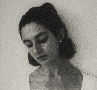  Georgina Berbari, M.A., E-RYT | Session 3- Movement, Breathing & Awareness | 1:00pm-2:00pm
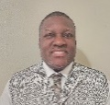  Dr. Anthony Murray | Session 4- Neuroscience of Mathematics Learning | 2:00pm-3:00pm
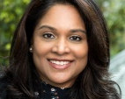  Dr. Julio Gonzalez | Session 5- Meeting the Needs of Individuals with Exceptionalities from Birth through College | 3:00pm-4:00pm
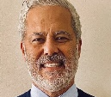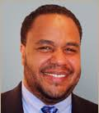  Dr. Duncan Quarless  Dr. Shalinie Sarju  Dr. Fernando Nieto | Session 6- Fostering the Development of Affective and Durable Skills to Improve Persistence in STEM Fields | 4:00pm-5:00pm
Dr Fernando Espinoza Image
Image Chancellor Young
Dr Collen Keating
Image
Dr Aliya Holmes
Image
Dr Maureen Gillette
Image
Dr Nicole Sieben
Image
Dr Josefa Pace
Image
Dr Nicole Liebowitz & Alyssa Marino images
Dr Michelle Withers Image
Dr Fernando Nieto Image
Dr Jevon Hunter Image

