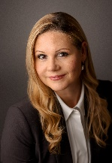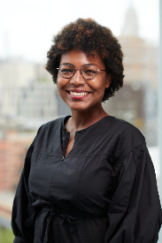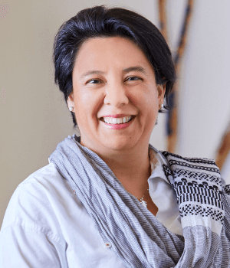

Dr Livia Gama Fagundes

Logo Old Westbury 2023 Summer Institute

**Conference Presenters at a Glance**

**Day I July 24th : Promoting Equity in Education**

**Session 1                                                       Session 2**

**Day II July 25th : Promoting Equitable Education in STEAM**

**Session 1 Session 2**

**Day III July 26th : Assessment & Data Collection**

**Session 1 Session 2**

**Day IV July 27th : Culturally Responsive Pedagogy**

**Session 1 Session 2**

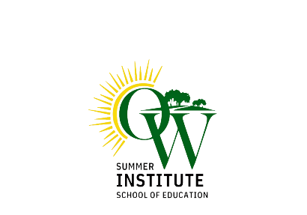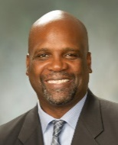

*". . . With Literacy, Liberty, & Justice for All:" Making Culturally Relevant Education Real in the Classroom*"

**Dr. Jevon Hunter**

**Christopher A. Garofalo**

***"****Supporting students with exceptionalities"*

**Dr. Livia Gama Fagundes**

*"Understanding the Changes in Reading*

*Instruction to Help Children Learn to Read in*

*Classroom Contexts*

**Dr. Colleen Keating**

*“Differentiated Instruction:*

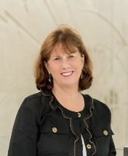

**Dr. Maureen Gillette**

**"***Creating equitable classrooms,*

*schools and districts*"

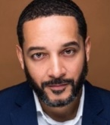

*"How do you show up in your Equity?"*

**Dr. Shawn Rux**

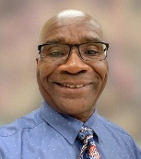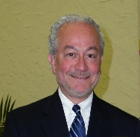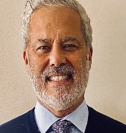

*"Equity as value-added dimension in mathematics*

*teaching and learning "*

**Dr. Blidi Stemn**

**Dr. Fernando Espinoza**

*“Learning Science through inquiry within a Social*

*Justice context"*

**Nicole Liebowitz**

**& Aylssa Marino**

"Social Emotional Learning (SEL)"

**Dr. Cristina Notaro**

*“Grant Writing"*

**Dr. Fernando Nieto**

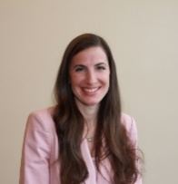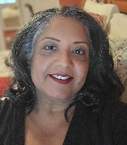

**Apple Education**

*“iPad and Student Assessment"*

**Dr. Nicole Sieben**

**Dr. Shanti Konkoth**

**Dr. Michelle Withers**

**Dr. Gina Semprebon**

***"****Data Collection and Assessment in K-12 and*

*College Classrooms"*

***“****Using Assessment to improve student learning*

*outcomes"*

***"****Developing inclusive classrooms in STEM"*

*"Designing Learning Environments with Equity in Mind:*

*Culturally Relevant Education as an Act of Educational*

*Dignity and Justice "*

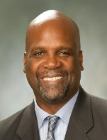

**Keynote**

**Dr. Jevon Hunter**

**Dean Diana Sukhram**

“Call to action/Next steps

2023 Summer Institute Learning Conference”

**Closing Remarks**

*” Boosting STEM success for underrepresented groups"*

**Dr. Aliya Holmes**

**Apple Education**

*“Everyone Can Code”*

*“A TIME to CURE the failed* ***“****STEM pipeline“model*

**Dr. Josefa Pace**

*“Effective online teaching strategies"*

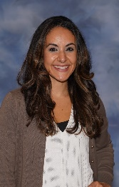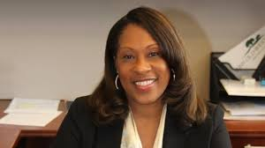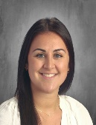

**Apple Education**

*“Technology: Accessibility "*

**Dr. Priscilla Zárate & Richard Bellis**

“Bilingual Ed.- What ELL’s/MLL’s need but often

don’t get: a historical look at advocacy and data"

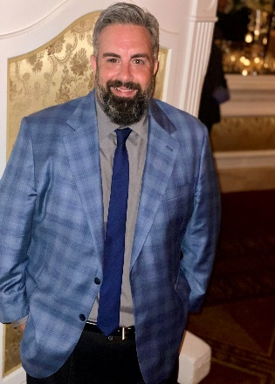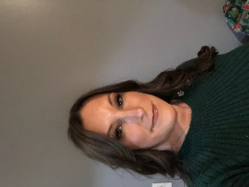

“Appropriate Technology use in teaching and learning"

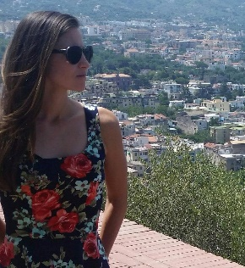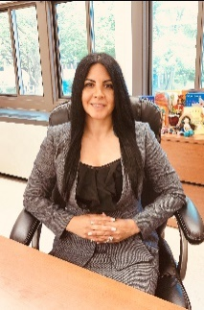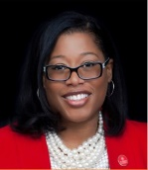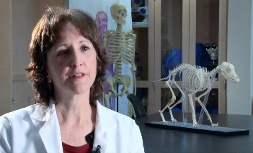

**Chancellor, NYS Board of Regents, Lester W. Young, Jr.**

“ Rethinking Education "



*“Taking Action on racial Equity and Justice”*

**Apple Education**

*“Art as a tool for empathic teaching "*

**Cris Scorza &**

**Dyeemah Simmons**

**Dr Fernando Espinoza Image**

Image Chancellor Young

**Dr Blidi Stemn Image**

Dr Shawn Rux

Image

Dr Collen Keating

Image

Dr Jevon Hunter

Image

Dr Christopher Garofolo

Image

Dr Aliya Holmes

Image

Dr Maureen Gillette

Image

Dr Priscilla Zarate & Richard Belis

Images

Dr Nicole Sieben

Image

Dr Shanti Konkoth

Dr Josefa Pace

Image

Dr Nicole Liebowitz & Alyssa Marino images

**Dr Gina Semprebon**

**Dr Michelle Withers Image**

**Dr Fernando Nieto Image**

**Dr Jevon Hunter Image**

**Dean Diana Sukhram**

**image**